Title: | Window Lifter  SW Component Design Specification

History
Issue status  (Index) | Maturity/Date  (draft/invalid/valid)  (dd-mmm-yyyy) | Author  Department | Check/Release  Department | Description
1.0 | Draft  26-June-2015 | Erick Salinas | AEP | Creation of the document.
2.0 | Draft  30-July-2015 | Erick Salinas | AEP | Traceability with requirements documents.
3.0 | Draft  2-July-2015 | Erick Salinas | AEP | Adding new requirement for correct operation. Described in final section.

Table of Contents
1 Purpose 4
2 Definitions and abbreviations 4
3 Realization constraints and targets 4
3.1 Input and Outputs 5
4 SW Conceptual design 5
5 Component internal breakdown 6
5.1 Functional Decomposition 6
5.2 Function void Func_500us(void) 7
5.3 Function void Delay(T_LONG time) 8
5.4 Function void Out_Leds(void) 9
5.5 Function void State_Machine_1ms(void) 9
6 Comments and Disclaimer 11

Purpose

This document is designed to explain the use and implementation of the software created to control de window lifter module, and to have a better understanding of the code design.

Definitions and abbreviations
Definitions
PIT Periodic Interruption Timer
GPIO General Purpose Input Output

References
N° | Document name | Reference
1 | Window lifter requirements | ⁽¹⁾
2 | Traceability matrix | ⁽²⁾

Realization constraints and targets

The system consists in 10 LED’s representing the movement of a car window. All LED’s turn on represent the window is closed and every LED turning off represent one level of the window opening. It has two buttons to activate the rise and decline movements. It also detects pinch situations of the window simulated by an extra button. The system can detect invalid button press if they do not last more than 10ms. The movements have two different ways of operation depending on the duration of the button press, manually or automatically. If the button press last more than 500ms the system will increase one level, and if it last less than 500ms it will activate the automatic operation increasing the level until it reaches its maximum. Finally if the antipinch button is detected it will stop the rise movement and return to the open state. For more information on the system functionality check Window lifter requirements ⁽¹⁾ and Traceability matrix ⁽²⁾ description.

Input and Outputs

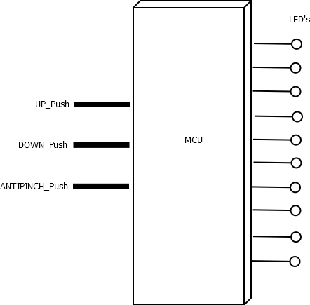

Figure 1 HW Inputs/Outputs

SW Conceptual design

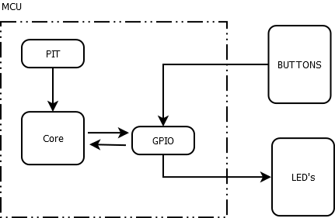

Figure 2 Conceptual Design

Component internal breakdown

Functional Decomposition

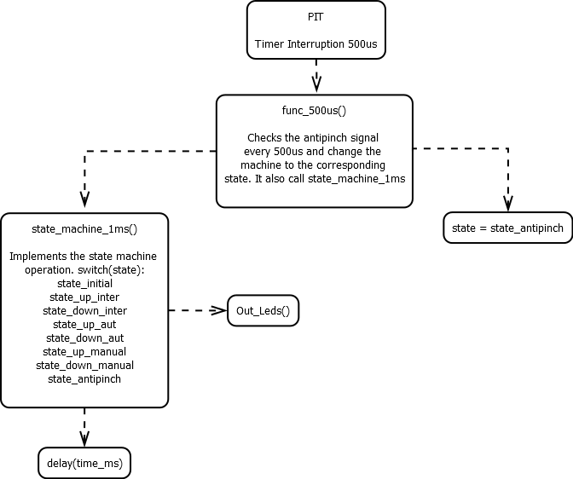

Figure 3 Functional Decomposition

Function void Func_500us(void)
Description | This function is call by a PIT interruption every 500 us. Every second time this function is called, the function Func_1ms(void) is called. It’s also reading the button for the anti-pinch every time is called to change the state of the state machine.
Parameter | Void
Return Value | Void
Precondition | Can only be called by the invocation of the PIT interruption.
Post condition | If the antipinch is activated it will change the state machine to the antipinch state.
Requirements | R14

Behavior

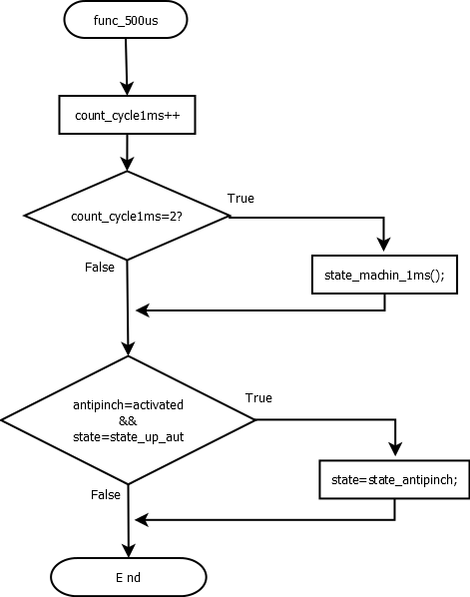

Figure 4 func_500us

Function void Delay(T_LONG time)
Description | This function makes a delay time by using the module STM. As it is based on while structure, it won’t let the program to continue until it is done.
Parameter | T_LONG time: it defines the time in mili seconds the function is going to wait.
Return Value | Void
Precondition | It is called when a delay that stops the system is desired.
Requirements | R5, R11

Dynamic Behavior

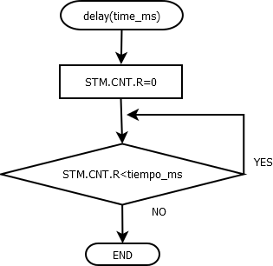

Figure 5 delay

Function void Out_Leds(void)
Description | This functions translate the variable level to the output LED’s.
Parameter | Void
Return Value | Void
Precondition | It is called after there’s been a change in the value of the variable level, to reflect the state of the system.
Requirements | R2, R4,

Dynamic Behavior

It consists on 10 “if” structure that activate the output pins for the LED’s depending on the value of the level variable.

Function void State_Machine_1ms(void)

Description | This function contains the state machine that controls the different situations on the system. In the next diagram is explained the actions made in each state and the conditions to change between them. All states are reachable within the function, except for the state_antipinch that is activated from the func_500us if ANTIPINCH = ACTIVATED more than 10ms.
Parameter | Void
Return Value | Void
Precondition | Is called from the Func_500us() every 1ms.
Requirements | R5, R7, R9, R10, R11, R15*, R16, R17, R18, R19

Dynamic Behavior

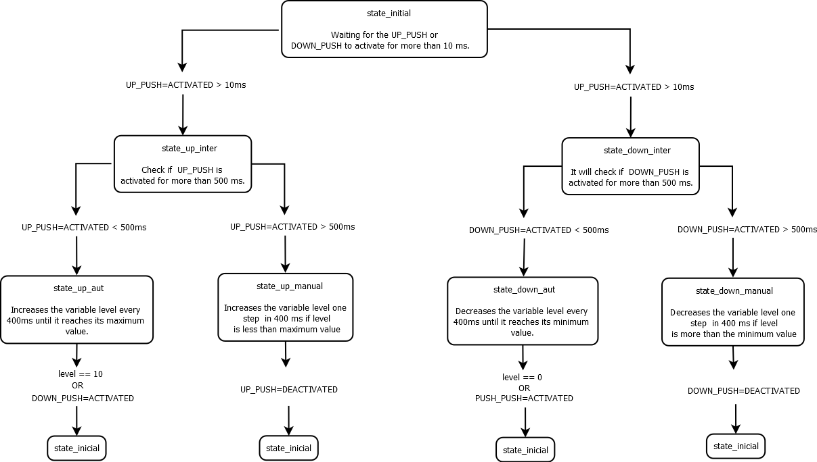

Figure 6 state_machine_1ms

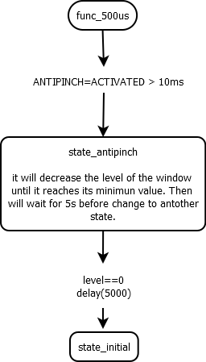

Figure 7 state_antipinch

Comments and Disclaimer

As is mentioned in the Traceability matrix⁽²⁾ some of the client requirements were ambiguous, specifically R10, R14 and R15. For the R10 and R14 it is proposed to consider the antipinch signal source something different than a button. So this means that it can be activated at the same time as another button. So it is possible to interrupt the automatic and the manual up movement. This new consideration comes from the clarification of the R15. When it mentions that the antipinch must work when the movement is up, now we can consider that it also includes the manual mode and no only the automatic.

It was decided also to include a new requirement to the client’s list. As is mentioned in the Traceability matrix ⁽²⁾, the R19 was a new requirement added to complete the correct operation of a window lifter. It is consider dangerous to have an operation that cannot be stopped by a user decision, but only by an antipinch sensor that should only for emergency. So it was decided that in the automatic operation mode, the movement should stop if the opposite button of the direction were pressed. That means than an up movement in automatic mode can be stop by pressing the down button, and will leave the system waiting for a new instruction. If the new button remain press for more than the normal activation time, it will activate the manual mode.

Finally in the 5 seconds of waiting after the antipinch operation the down LED remain on to indicate the system is not ready yet to continue.

